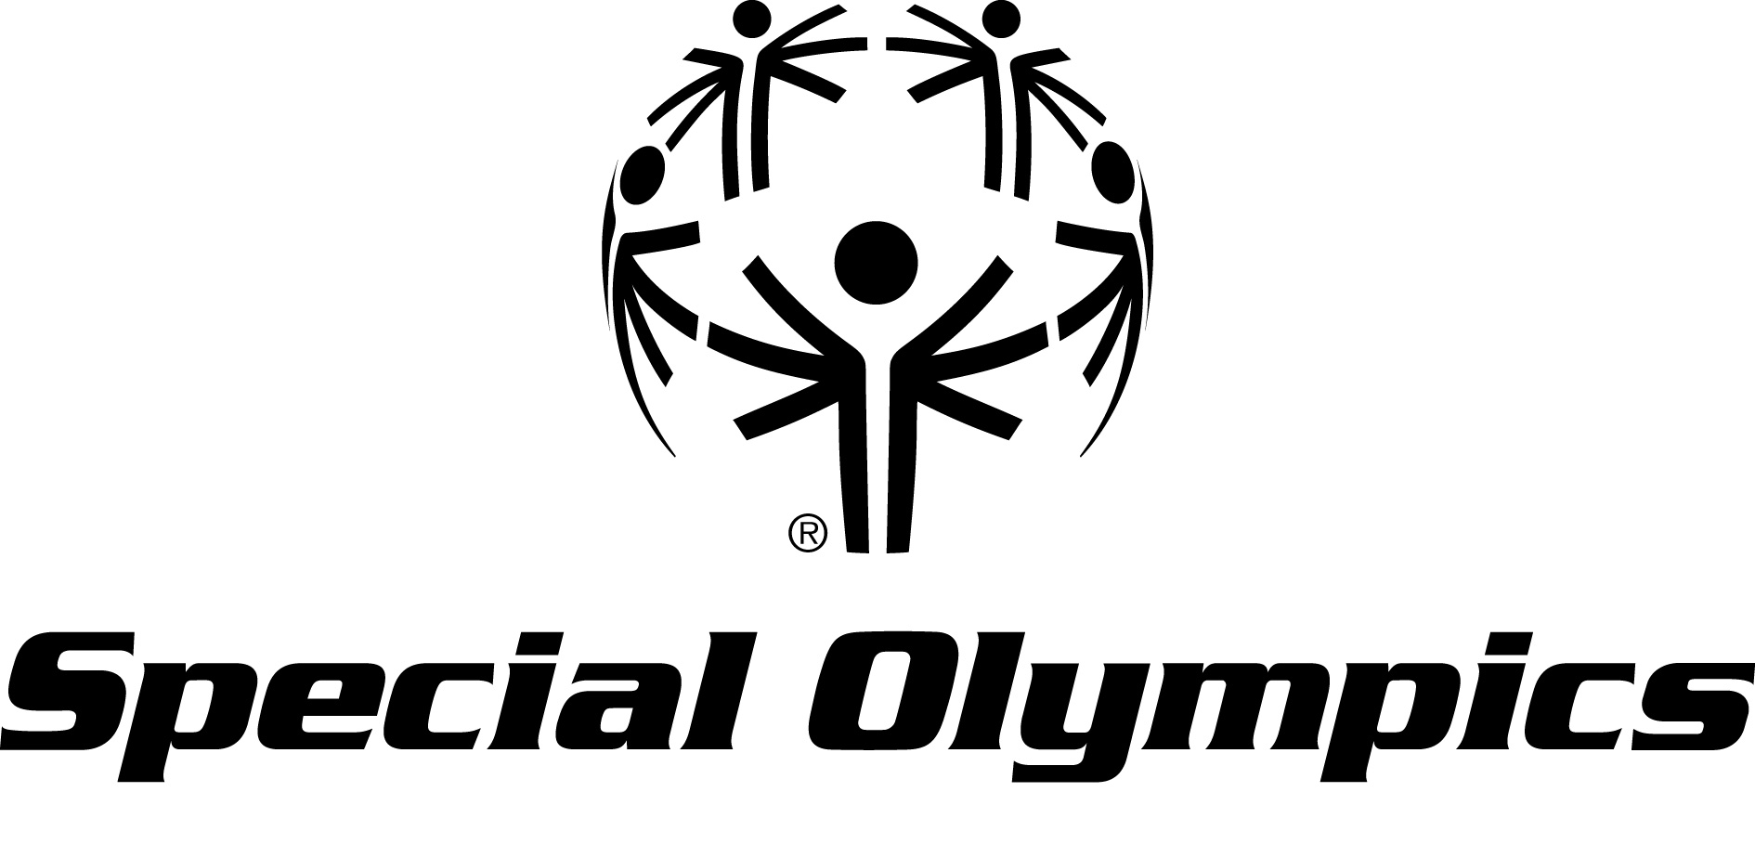

Social Media Activation
Special Olympics World Summer Games Los Angeles 2015
Press Announcement

Twitter: If you are tweeting about or from the LA 2015 announcement, please use the hashtag #LA2015 and mention (with the @ symbol) @SpecialOlympics.

Sample messages:
- All eyes will be on the biggest stars in #LA2015 when @SpecialOlympics athletes compete in the World Summer Games! http://bit.ly/j7jKz
- Congrats to LA, just named host city for the 2015 @SpecialOlympics World Summer Games! #LA2015 http://bit.ly/j7jKz
- Excited to share the news that LA will host 7,000 @SpecialOlympics athletes for the 2015 World Games! #LA2015 http://bit.ly/j7jKz

If you are an extra savvy tweeter, take a mobile pic and upload it and mention @SpecialOlympics and use the hashtag #LA2015

 Facebook: First, please go and "like" the Special Olympics page, www.facebook.com/SpecialOlympics. Then when you mention Special Olympics in a status update, please use the "@" symbol and it should provide you a drop down menu to link to our page in your post.

Sample messages:
- Congrats to the city of Angels, just named host site for the 2015 @Special Olympics World Summer Games!
- Proud to announce that Los Angeles will welcome more than 7,000 Special Olympics athletes to compete in the 2015 Special Olympics World Summer Games!
- Post a picture from the announcement to your wall with one of those messages.

